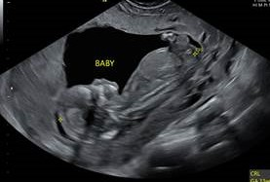
“I was able to see the baby’s spine this time. I don’t think I saw it last time.”
“Dana” continued, “I just made my decision 3 days ago to continue with the pregnancy, so this ultrasound helped...it's the right decision." As we go to know Dana, it seemed that a lot of prayers and tears brought her to this point.
Dana came to Waterleaf very conflicted about her pregnancy. Along with her husband “John” they made an appointment at Planned Parenthood to have an abortion, but when they arrived, she could not go through with it. She left PP after an hour tormenting over how to tell John of her decision. Their relationship was already strained; Dana expressed her sadness that this pregnancy seems to be the final straw that will end her marriage. Dana needed to make her decision about this baby before telling her parents about the pregnancy. Her mother had an abortion years ago and told Dana that she still regrets it. To add to Dana’s stress, she lost her job and likely her insurance as well. Her sister, however, let Dana know of her support and attended her most recent ultrasound at Waterleaf with her. The two of them were excited about the images of the baby that was quite active.
Dana is currently working with Waterleaf’s Aspire Education and Resource Center to get the community and insurance resources she will need to have her baby.

