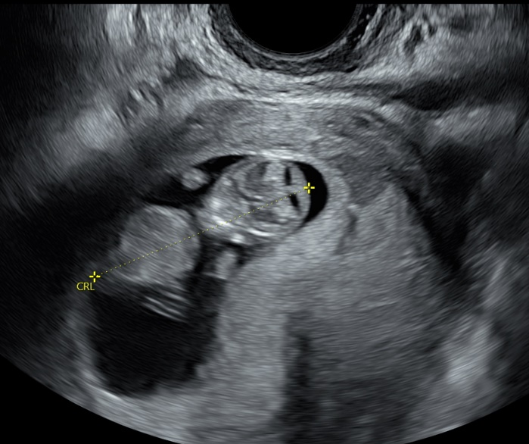
Anna’s Story
When “Anna” first visited Waterleaf, she stated she did not feel ready to have another baby. She explained that her sister is also pregnant and found out that her sisters’ child had some birth defects. Anna wondered if her baby will also be at risk for hereditary birth defects, so she was considering abortion. She told her Waterleaf advocate “I have to figure things out because I care for my sister. It would be great to give my daughter a sister or brother though.” Anna mentioned her frustration with getting insurance coverage. At a return visit, Anna brought her husband, “Mike”, who wanted to see the baby that week. They had not yet told anyone about the pregnancy, preferring to wait and talk more after they saw the ultrasound. During the ultrasound, Mike stared at the screen the entire time. Anna was talkative, commenting that the baby looked like a little gummy bear.
After lengthy consideration, Anna and Mike have now decided to parent their baby. Her sister has been very supportive of her decision. She commented that the Waterleaf resource specialist was very helpful and comforting at her previous visit, so she is feeling more secure about getting insurance coverage.
Anna and Mike have told their 4-year-old daughter that they are expecting a new baby and report she’s always talking about her new baby brother or sister.

